**Question #3**

The first and most obvious simulation that we thought of doing was when all members were down. This would eliminate the effects of Coriolis and gravity which should results in an all zero state if no torque is given to each motor. The following depicts this case:

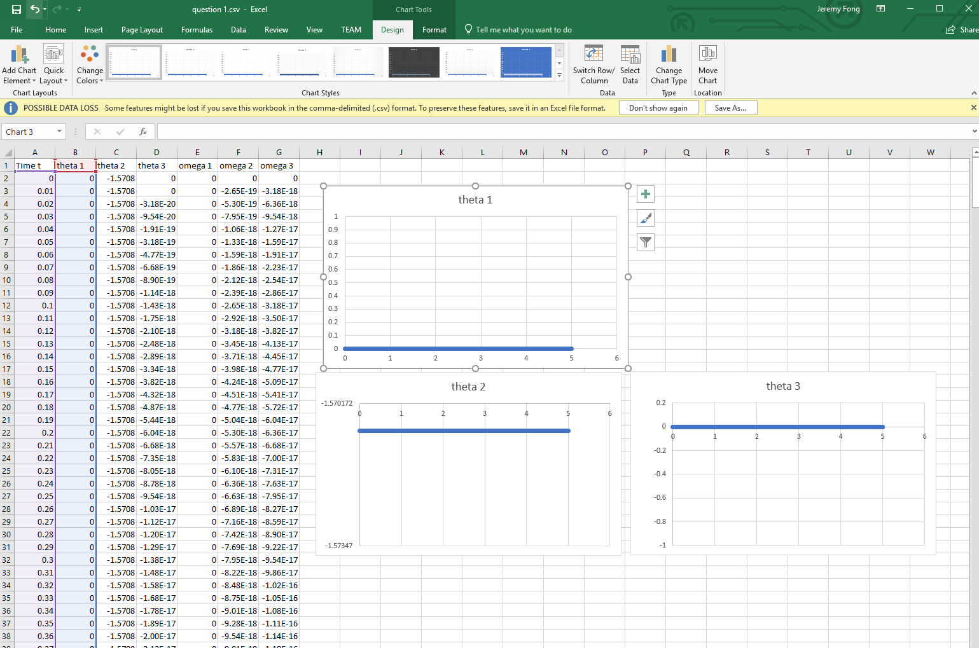

As expected, both arms 1 and 3 are at 0 degrees and arm 2 is at –pi/2. Due to no forces applied, this is an equilibrium state with no active parts (basically like a dead arm).

The second simulation was another equilibrium one but this time, we wanted all data to result in 0. Firstly, this would mean that the initial conditions are all zero (not -pi/2 like in the first example). Therefore, arm 2 would be suspended in the air, 90 degrees from arm 1, while arm 3 is parallel to arm 2 since its relative angle is also 0. Secondly, because of gravity, the torque given to the motors would have to be strong enough to keep the weight of both arms elevated. As calculated, the torque from motor 1, 2 and 3 would have to be:

T1 = 0

T2 = m2 * g * l2/2 + m3 * g * (l3/2 + l2) It has to carry both its weight and that of the third arm

T3 = m3 * g * l3/2

The results are as expected:

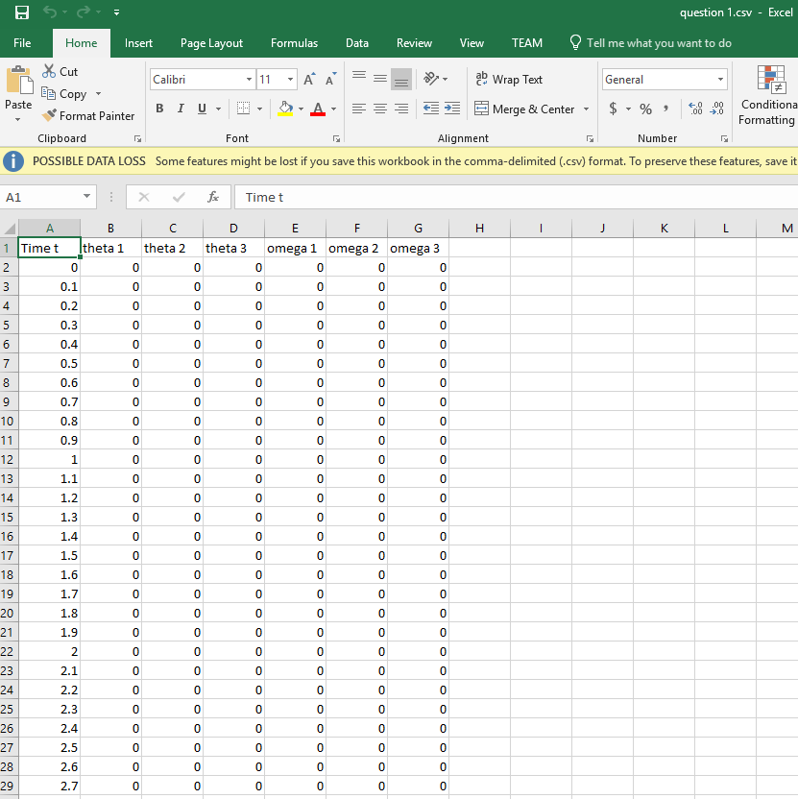

Full equilibrium! (There is a section in the code that shows this calculation) This means that the arm would have no rotation in yaw and would have both arm 2 and 3 suspended 90 degrees in the air! This is extremely useful because this is how we will be able to stabilize the arm so that it can grab an object.

To make sure the previous data was not just fluke, we also added a rotation to the arm 1 with a Torque one 1:

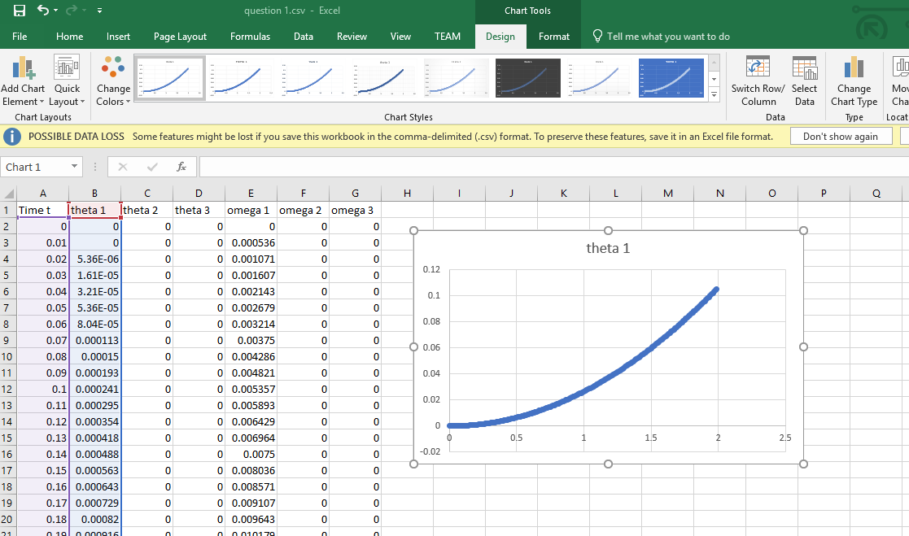

The arm 2 and 3 would still be “levitating” but the entire apparatus would be rotating about arm 1.

The third simulation we had arm 2 and 3’s initial at pi/3 and -pi/3 respectively. This was to understand another configuration of the arms to reach equilibrium:

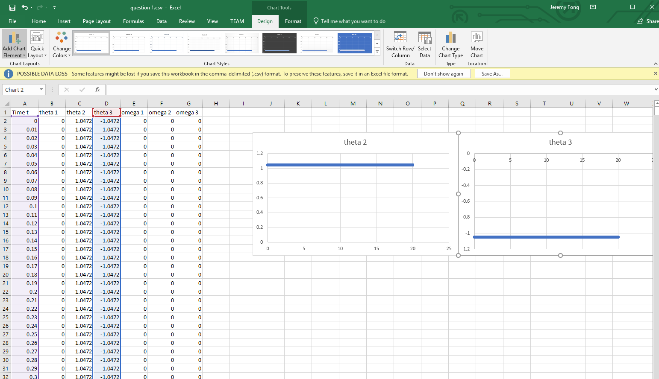

These simulations show that the logic behind the code works. The next task is to understand how to control them properly, so they behave the way we want. So far, it has been challenging because a lot of the behaviour is sporadic and unpredictive. This is why most arms are built with control systems.